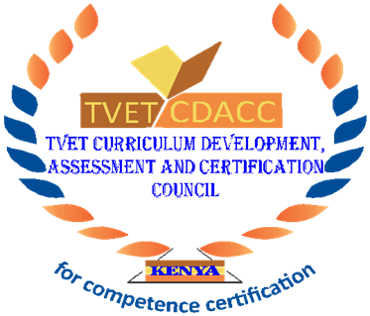

TVET CURRICULUM DEVELOPMENT, ASSESSMENT AND CERTIFICATION COUNCIL (TVET CDACC)

STAKEHOLDERS COMMENTS TEMPLATE 2023

RPL ASSESSMENT AND CERTFICATION GUIDELINES

No. | Page/ Paragraph/ Figure/Table | Type of comment (General/Technical /Editorial) | Comments | Proposed Change | Observations of The TVET CDACC Secretariat

NOTE: Attach additional comments if it can’t fit on columns provided but keep to the template format

